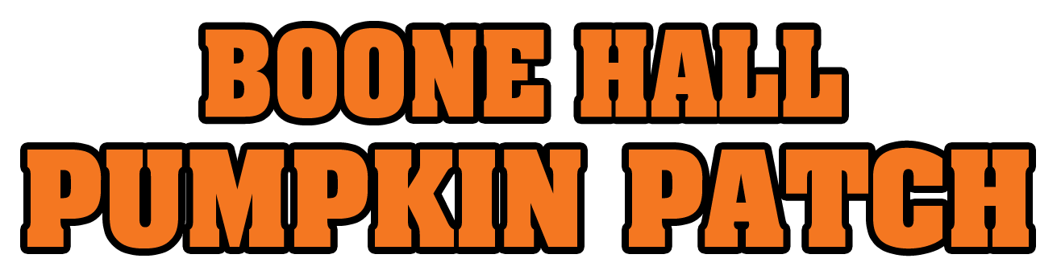
FAQ About The 2021 Boone Hall Pumpkin Patch

1. Overview of this event?
The Boone Hall Pumpkin Patch has grown to be one of the largest fall festivals in the state of South Carolina. This year will mark the 25th year for this event which has become a fall tradition for people of all ages. The good news for 2021 is that we will return to presenting a full event with all the attractions that are festival favorites.

2. What will be available at the event?

The popular Family Friendly Monster Hayride returns with event goers once again being able to hop aboard the tractor hayride which will wind its way through a variety of colorful themes and scenes.

The All-American Petting Zoo will be on hand on all open days.
- Two of the largest inflatable jump pillows in the state.
- Playground area with slides, swings, and more.
- Inflatables provided by Happily Ever After.
- Explore the giant eight-acre Certified SC Grown corn maze.

And of course, there will be a variety of pumpkins of all shapes, sizes, and colors available for purchase along with all those delicious festival foods we all love.

3. How much is admission and what is included?

Admission
$12 - Ages 2 and up
Children one and under admitted FREE with accompanying adult
Advance tickets can be purchased online at:
https://www.boonehallplantation.com/special_event/the-boone-hall-pumpkin-patch/
Admission tickets will also be sold at the entrance to the event while available.

The attractions listed above are all included with admission for one price.
Pumpkins and festival foods require a separate purchase.

FAQ About The 2021 Boone Hall Pumpkin Patch

4. What the days and hours of operation for this event?

Friday October 1 - 10AM-6PM

Saturday October 2 - 10AM-6PM

Sunday October 3 - 12pm-6pm

Friday October 8 - 10AM-6PM

Saturday October 9 - 10AM-6PM

Sunday October 10 - 12pm-6pm

Friday Oct. 15 - 10AM-6PM

Saturday October 16 - 10AM-6PM

Sunday October 17 - 12pm-6pm

Friday October 22 - 10AM-6PM

Saturday Oct. 23 - 10AM-6PM

Sunday October 24 - 12pm-6pm

Friday October 29 - 10AM-6PM

Saturday October 30 - 10AM-6PM

Sunday October 31 - 12pm-6pm

PLEASE NOTE THAT THE CERTIFIED SC GROWN CORN MAZE WILL STOP ADMITTING EVENT ATTENDEES INTO THE MAZE ONE HOUR BEFORE CLOSING ON OPEN DAYS.

FAQ About The 2021 Boone Hall Pumpkin Patch

5. Where is the event located?

The Boone Hall Pumpkin Patch is located at 2434 N. Hwy. 17 in Mount Pleasant, S.C.
Please do not go to the main entrance to Boone Hall Plantation on Long Point Road. You cannot get into this event from there.

6. Is the hayride scary?
The Family Friendly Monster Hayride is designed to be fun for all ages. It has colorful themes and scenes all along the hayride trail. Halloween type characters, creatures, costumes, and setups can be seen on the ride through the woods, but these parts of the trail are designed to be kid friendly. It is available only during daytime hours the pumpkin patch is open.
This hayride is not to be confused with the hayride that is presented only at night at Boone Hall Fright Nights as one of three attractions at that event. Boone Hall Fright Nights is a completely separate event from the Boone Hall Pumpkin Patch. All of the attractions presented at this night time event are designed to be scary and are not recommended for children under the age of 12.

7. Is there a corn maze at this year’s event?
Yes!! There is a giant eight-acre corn maze that this year is sponsored by the South Carolina Dept. Of Agriculture. The maze will present the recognizable Certified SC Grown logo as part of the design. It will have two mazes. One is a shorter maze for smaller children and people who do not want to walk too far. The other maze is longer and will challenge the most adventurous corn maze explorers.

8. Does paid admission to the pumpkin patch include admission to tour Boone Hall Plantation?

No. Paid admission to the Boone Hall Pumpkin Patch does not include admission to tour Boone Hall Plantation and vice versa. Paid admission to tour Boone Hall Plantation does not include admission to the Boone Hall Pumpkin Patch. They are two completely separate venues and require separate admission for both.

FAQ About The 2021 Boone Hall Pumpkin Patch

9. Are pets allowed?
Pets are not allowed unless they are a service animal.

10. What are the prices for pumpkins?
Carving - $.79 lb.
Decorative - $.89 lb.
Pie - $2.99 each
Mini - $1.99 each
Gourds - $1.89 lb.

11. Will there be food available at the event?
Yes!! There will be a variety of food and beverages available from a number of vendors. No coolers, concealed weapons, or outside food and beverages allowed.

